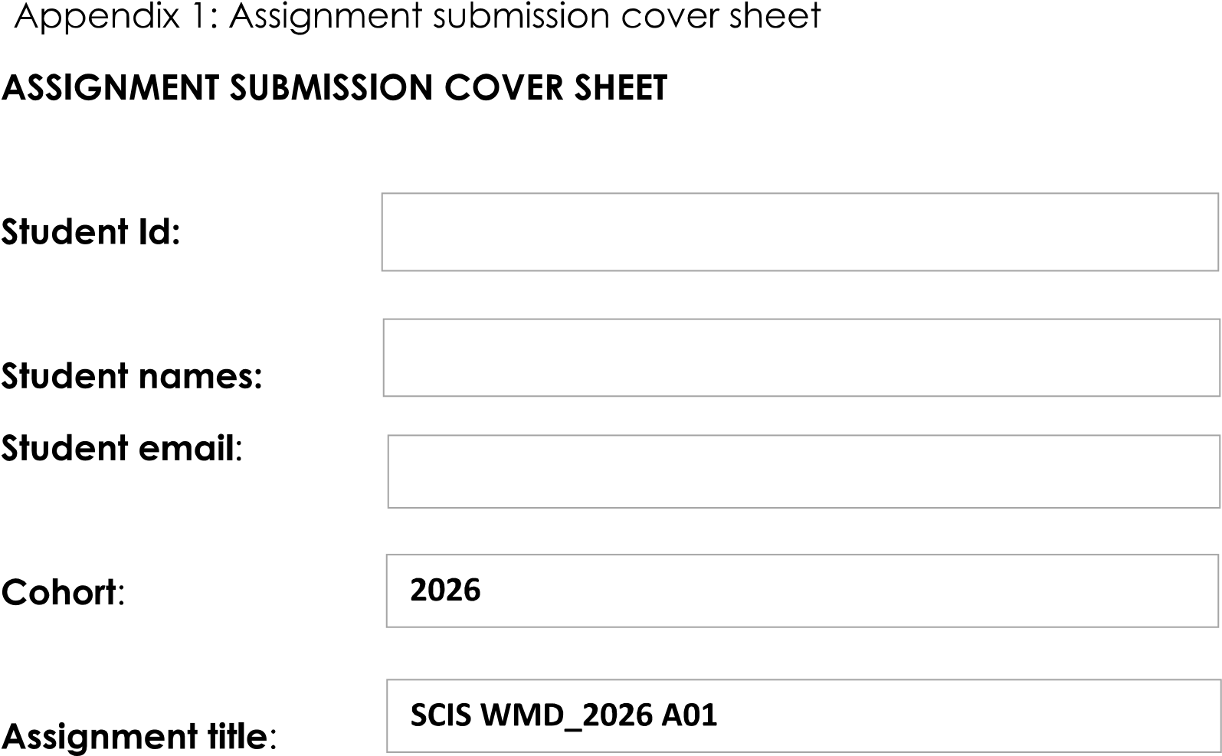
20 May 2026
Fcse25-009@thuto.bac.ac.bw
Maduo Sebudubudu
Fcse25-009

20 May 2026
M P Sebudubudu
Computer Systems Engineering

Table Of Contents

Chapter 1: Introduction & Project Scope
1.1 Website Specification

Chapter 2: Information Architecture & User Experience
2.1 Information Design & Taxonomy
2.2 Page Template Design

Chapter 3: Technical specifications & System Features
3.1Technical Brief
3.2 Features

Chapter 4: Testing, Deployment & Publishing
4.1 Quality Assurance
4.2 Publishing & Promotion

Chapter 5: Project review & Strategic Outlook
5.1 Future Developments / Recommendation

CHAPTER 1
1.1 Website Specifications
Website Objective & Goals
StreamStore is a modern e-commerce website built with HTML/CSS/JavaScript, localized for Botswana. The website objective is to provide a fully functional online marketplace where customers can browse, search, and purchase products in Botswana Pula (BWP). The primary goals are to: (1) showcase products with detailed descriptions and pricing, (2) enable seamless cart management and checkout, (3) provide a responsive mobile-friendly experience, and (4) deliver a localized experience with Botswana-specific formatting and content.

Target Audience
The target audience includes Batswana online shoppers aged 18-45, with intermediate to advanced technical aptitude. Users are comfortable with web browsing, online shopping, and mobile applications. Demographics span urban areas such as Gaborone, Francistown, and Maun, with growing smartphone penetration and internet access across all districts.

Type of Website
This is an e-commerce/marketplace website designed for product browsing, searching, filtering, and purchasing. The content type is transactional, focused on product listings, category-based browsing, and a shopping cart checkout flow.

CHAPTER 2
2.1 Information Design & Taxonomy
The website follows a flat information architecture with the following page structure:
Home (index.html) -> Shop (shop.html) -> Product Detail (product.html) -> Cart (cart.html) -> Checkout (checkout.html) -> Contact (contact.html)
Navigation paths follow the 3-click rule: any product can be reached within 3 clicks from the home page. The main navigation bar provides persistent access to all top-level pages. The site map follows a hub-and-spoke model with the Home page as the central hub linking to all sections.

2.2 Page Template Design
Wireframes were created to plan the layout and content placement for each page. These sketches define the structure before development.

Home Wireframe
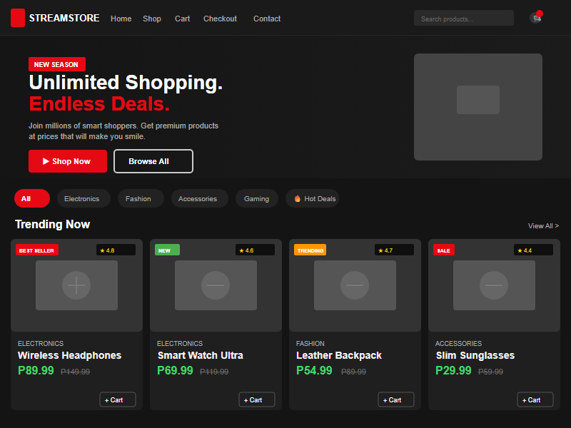

Shop Wireframe
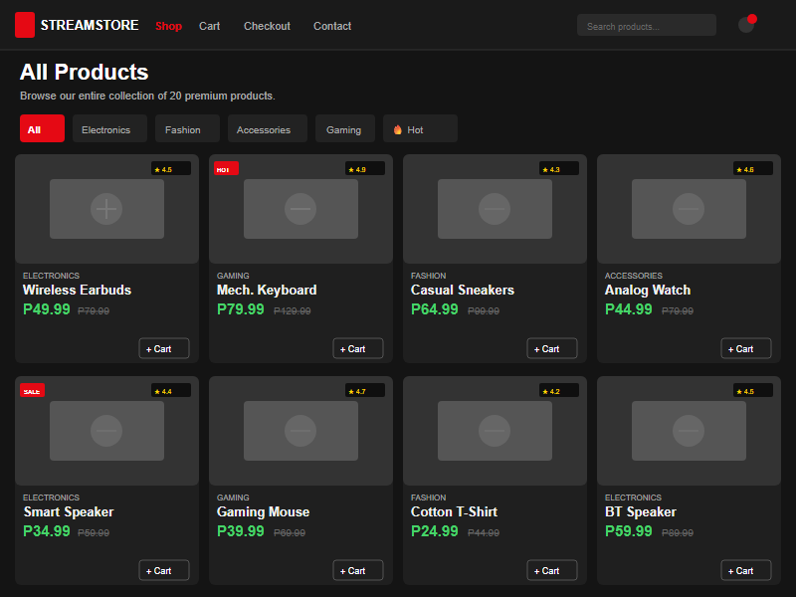

Checkout Wireframe
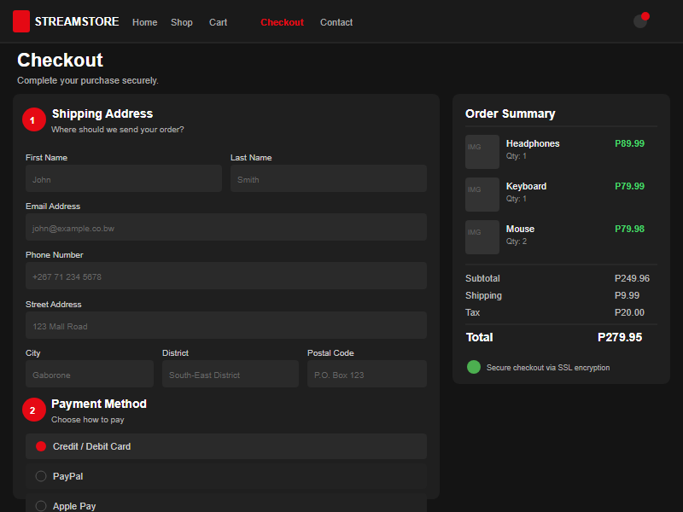

Wireframe Overview
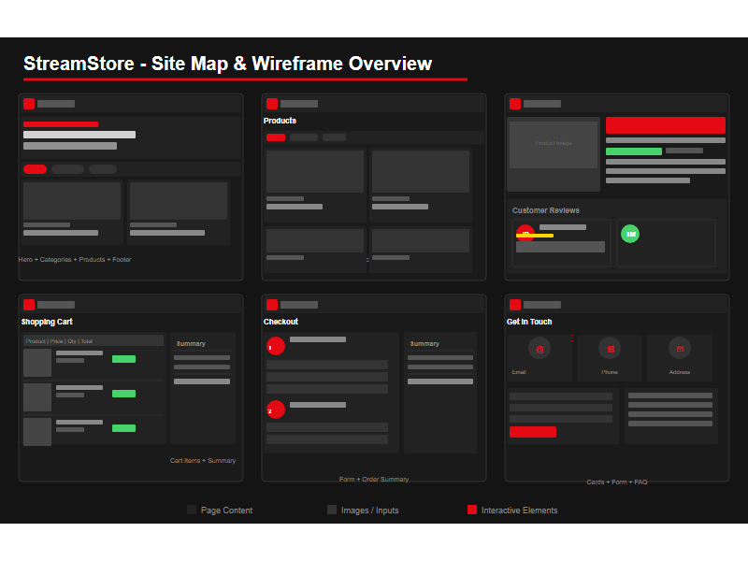

CHAPTER 3
3.1 Features
Free Shipping over P50 | 30-Day Returns | Secure Payment | 24/7 Support | Real-time Search | Category Filtering | Cart Management | Persistent Cart | Responsive Design | Botswana Localization | Hot Deals up to 70% off | District Autocomplete | BWP Currency Formatting | Mobile-First Layout

3.2 Technical Brief
The website was built using the following technologies and tools:
Frontend: HTML5, CSS3, JavaScript (Vanilla) - W3C standards compliant markup and styling.
Framework: Bootstrap 5.3 - responsive grid system, components, and utilities for rapid layout development.
Icons: Bootstrap Icons - consistent vector icon set for navigation, actions, and UI elements.
Font: Inter (Google Fonts) - modern sans-serif typeface for readability across devices.
Storage: localStorage - persistent shopping cart data across browser sessions without a backend.
Currency: Botswana Pula (BWP) - all prices displayed in Pula with proper formatting.
Development Tools: Visual Studio Code (editor), Git (version control), GitHub (repository hosting), GitHub Pages (website hosting), Microsoft Edge & Google Chrome (browser testing).

CHAPTER 4
4.1 Quality Assurance
The website was tested across multiple browsers and devices to ensure cross-browser compatibility and responsive behavior.

Home Page
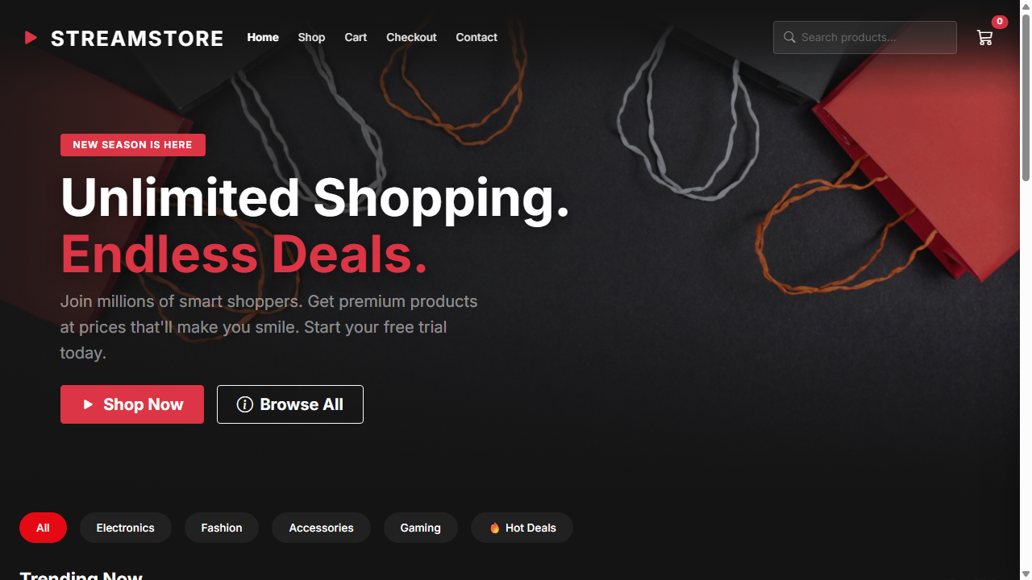

Shop Page
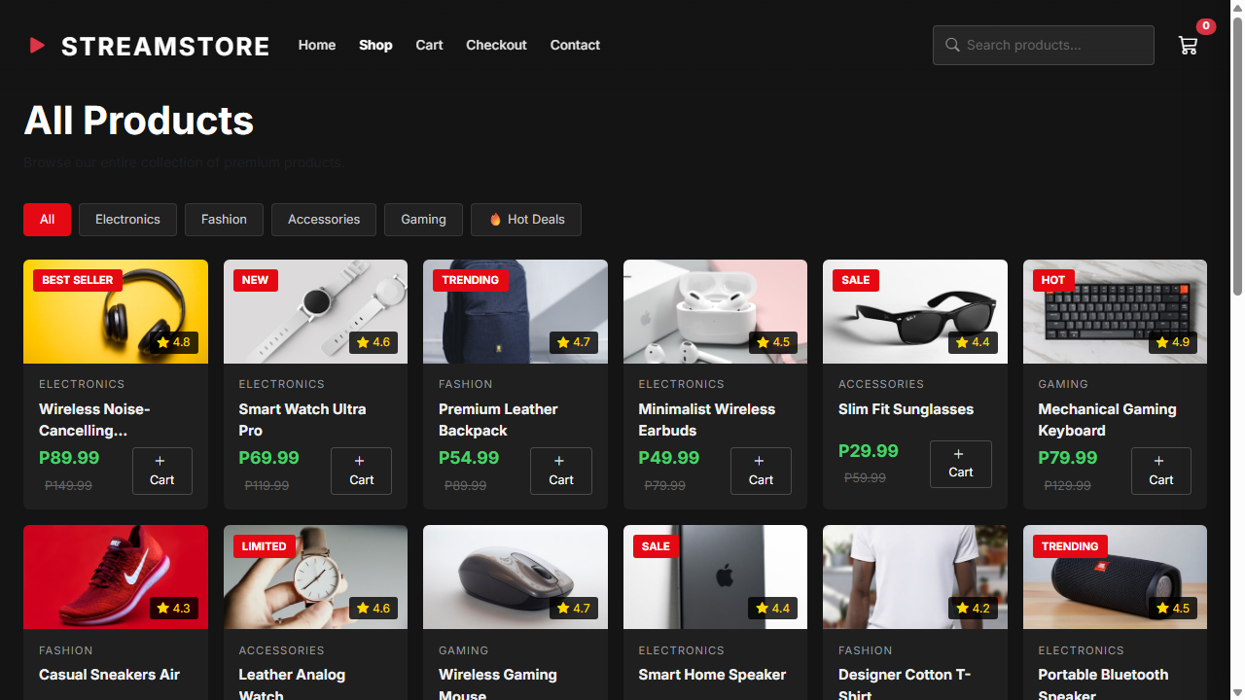

Product Detail
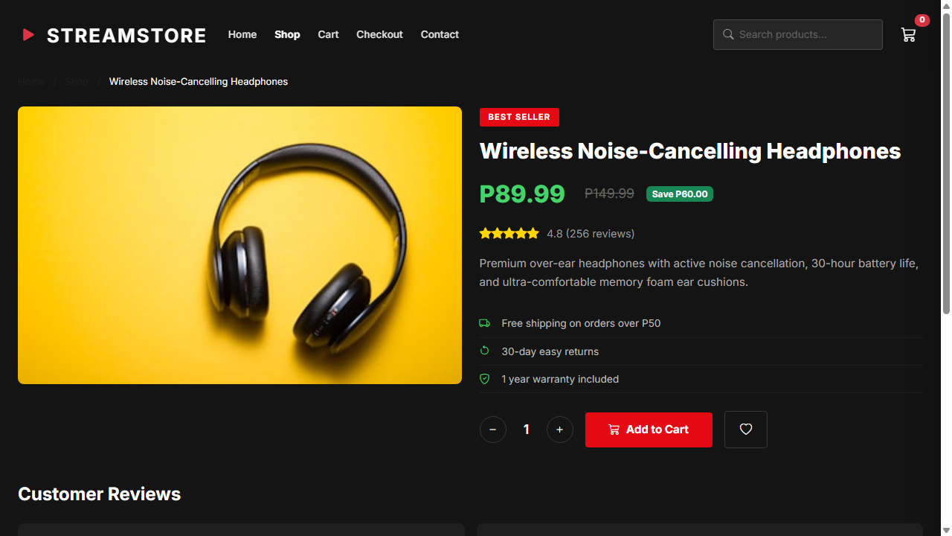

Cart Page
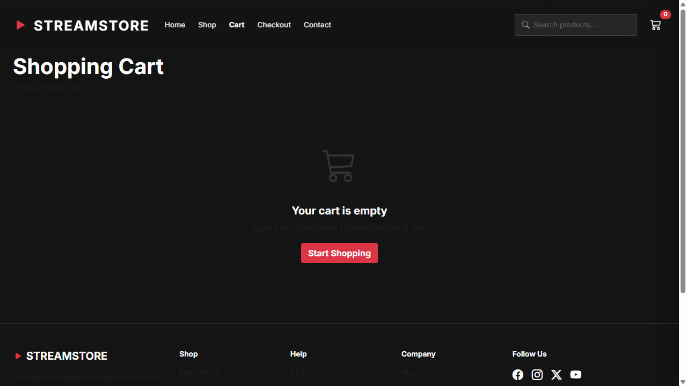

Checkout Page
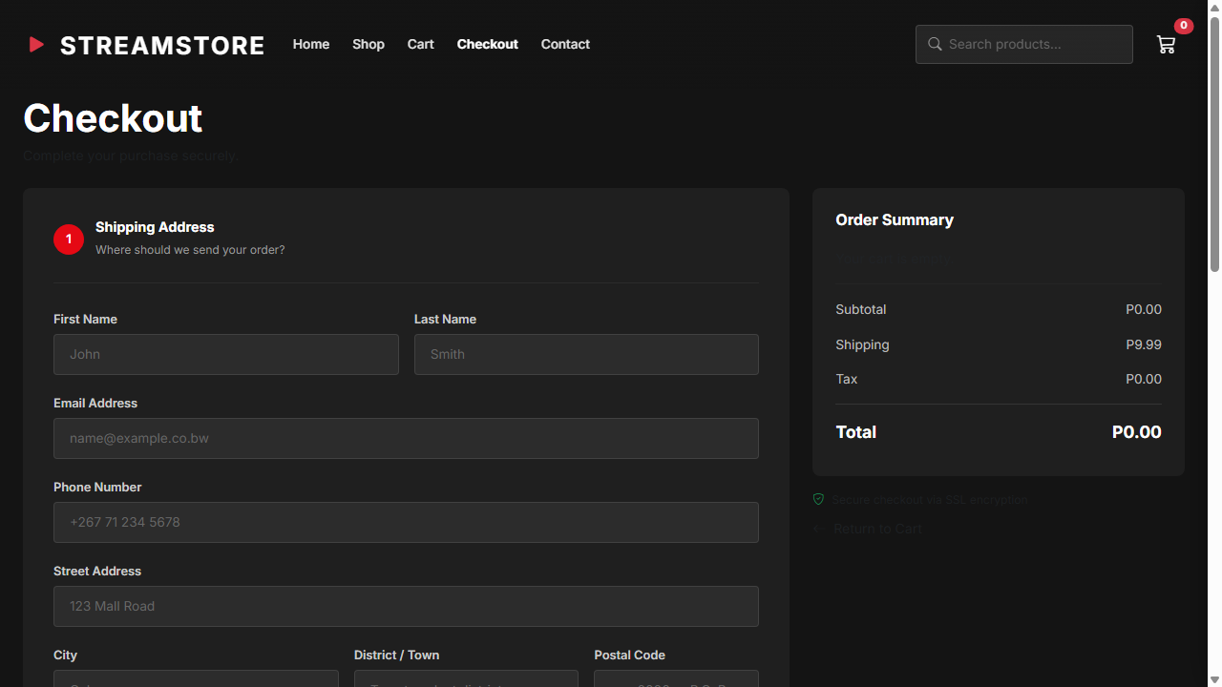

Contact Page
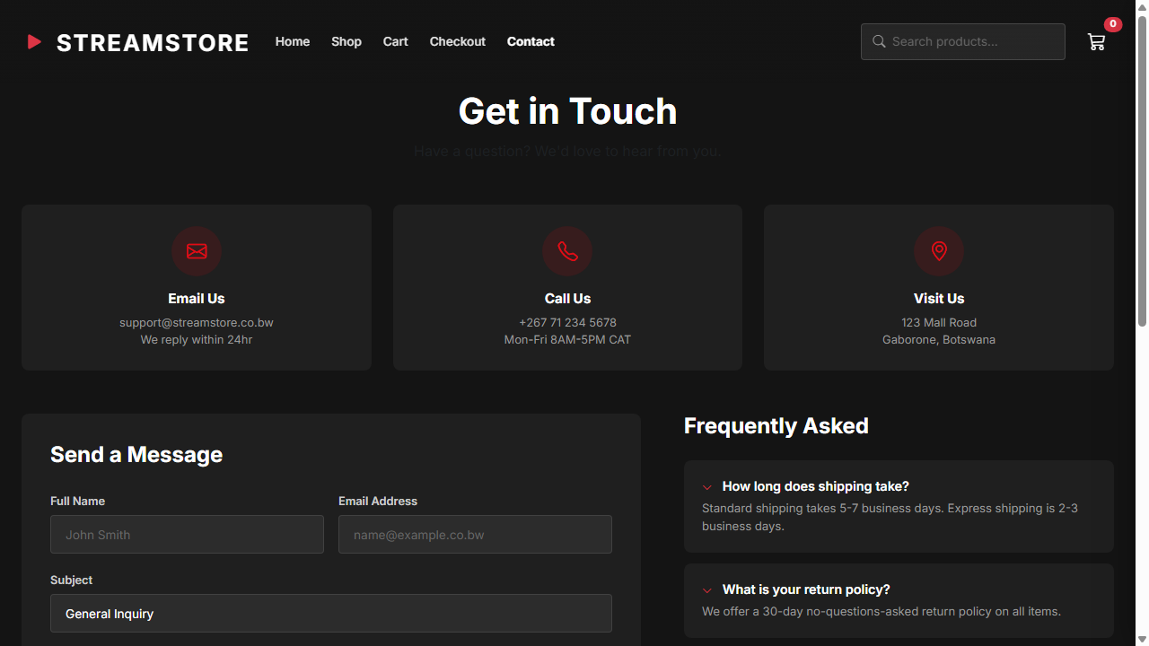

4.2 Publishing & Promotion
The website is hosted using GitHub Pages, a free static site hosting service provided by GitHub. The deployment process involved:
1. Initializing a Git repository locally using git init
2. Staging all website files with git add
3. Committing changes with git commit -m
4. Creating a remote repository on GitHub
5. Pushing the code using git push -u origin master
6. Enabling GitHub Pages in the repository settings to serve from the master branch
Live Website URL: https://fcse25-009thuto.github.io/streamstore/
GitHub Repository URL: https://github.com/fcse25-009thuto/streamstore.git
CHAPTER 5

7. Future Developments / Recommendations
To further improve the website, the following enhancements are recommended:
1. Backend Integration: Connect to a server-side database (e.g., MySQL, Firebase) for persistent user accounts, order history, and inventory management.
2. Payment Gateway: Integrate a Botswana-compatible payment processor (e.g., PayFast, Orange Money, or e-wallet) for real transactions.
3. Admin Dashboard: Build an admin panel for managing products, orders, and user data.
4. User Authentication: Add login/registration with session management for personalized experiences.
5. Performance Optimization: Implement lazy loading for images, code splitting, and CDN delivery for faster page loads.
6. SEO: Add structured data, meta tags, and sitemap.xml for better search engine visibility.

